Low Level Design

# Amazon Sales Data

|  |  |
| --- | --- |
| **Written By** | Author 1, Author 2 |
| **Document Version** | 0.3 |
| **Last Revised Date** |  |

**DOCUMENT CONTROL**

## Change Record:

|  |  |  |  |
| --- | --- | --- | --- |
| **VERSION** | **DATE** | **AUTHOR** | **COMMENTS** |
| 0.1 | 19- May -  2021 | Author 1 | Introduction and architecture defined |
| 0.2 | 20 - May -  2021 | Author 2 | Architecture & Architecture description appended and  updated. |
|  |  |  |  |
|  |  |  |  |

**Reviews:**

|  |  |  |  |
| --- | --- | --- | --- |
| **VERSION** | **DATE** | **REVIEWER** | **COMMENTS** |
| 0.2 | 21- May -  2021 | Author 3 | Unit test cases to be added |

**Approval Status:**

|  |  |  |  |  |  |
| --- | --- | --- | --- | --- | --- |
| **VERSION** | **REVIEW**  **DATE** | **REVIEWED BY** |  | **APPROVED BY** | **COMMENTS** |
|  |  |  |  |  |  |

**Contents**

1. **Introduction 04**
   1. **What is Low-Level Design Document? 04**

|  |  |  |
| --- | --- | --- |
| **1.2** | | **Scope 04** |
| **2.** | **Architecture 05** | |
| **3.** | **Architecture Description 08** | |
|  | **3.1** | **Data Description 08** |
|  | **3.2** | **Web Scrapping 08** |
|  | **3.3** | **Data Transformation 08** |
|  | **3.4** | **Data insertion into database 08** |
|  | **3.5** | **Connection with SQL server 08** |
|  | **3.5** | **Export Data from database 12** |
|  | **3.6** | **Deployment 12** |
| **4.** | **Unit** | **test cases 15** |

1. **Introduction**
   1. **What is Low-Level design document?**

The goal of the LDD or Low-level design document (LLDD) is to give the internal logic design of the actual program code for the House Price Prediction dashboard. LDD describes the class diagrams with the methods and relations between classes and programs specs. It describes the modules so that the programmer can directly code the program from the document.

## Scope

Low-level design (LLD) is a component-level design process that follows a step-by-step refinement process. The process can be used for designing data structures, required software architecture, source code and ultimately, performance algorithms. Overall, the data organization may be defined during requirement analysis and then refined during data design work.

# Architecture

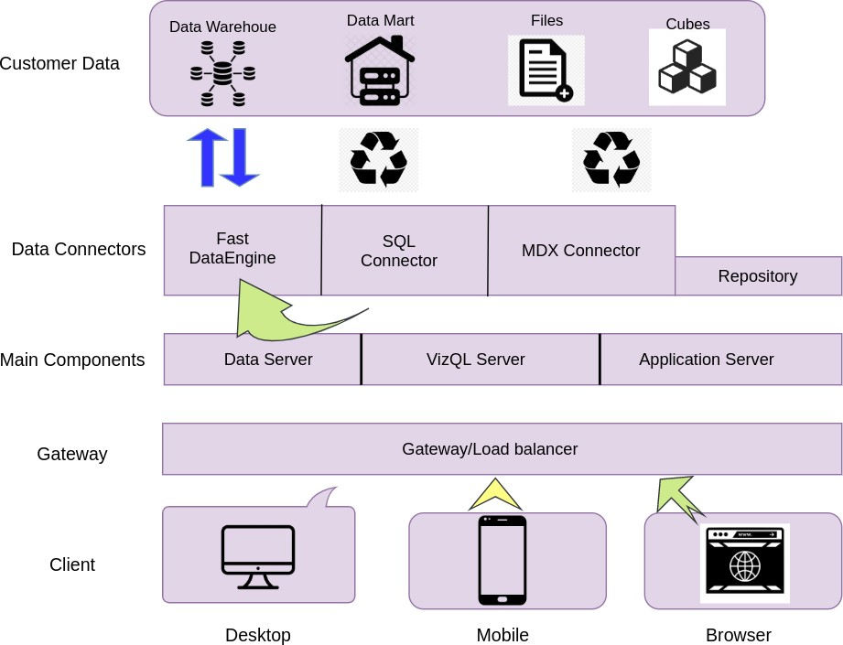

**Tableau Server Architecture**

Tableau has a highly scalable, n-tier client-server architecture that serves mobile clients, web clients and desktop-installed software. Tableau Server architecture supports fast and flexible deployments.

The following diagram shows Tableau Server’s architecture:

### Shape Description automatically generated with low confidenceLOW LEVEL DESIGN

**6**

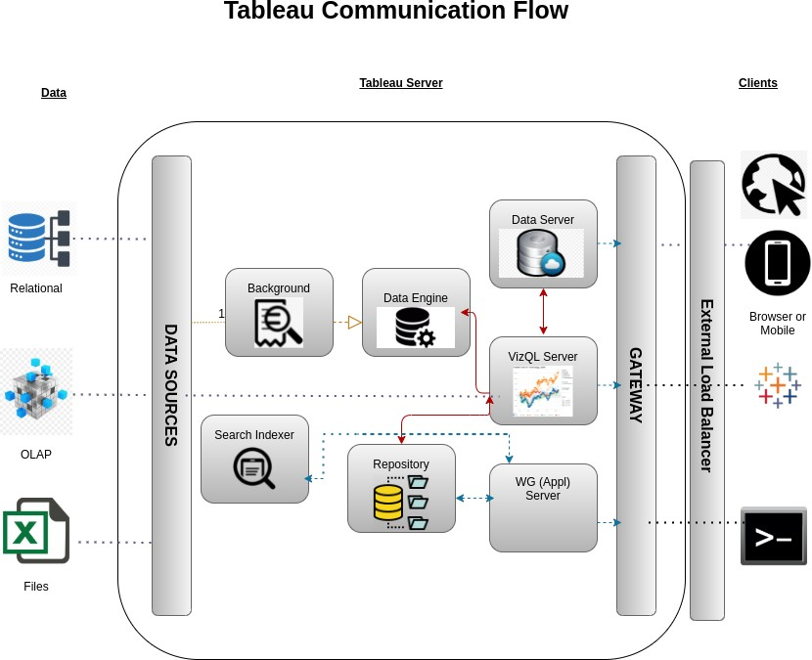

Tableau Server is internally managed by the multiple server processes.

**1. Gateway/Load Balancer**

It acts as an Entry gate to the Tableu Server and also balances the load to the Server if multiple Processes are configured.

**2) Application Server:-**

Application Server processes (wgserver.exe) handle browsing and permissions for the Tableau Server web and mobile interfaces. When a user opens a view in a client device, that user starts a session on Tableau Server. This means that an Application Server thread starts and checks the permissions for that user and that view.

1. **Repository:-**

Tableau Server Repository is a PostgreSQL database that stores server data. This data includes information about Tableau Server users, groups and group assignments, permissions, projects, data sources, and extract metadata and refresh information.

1. **VIZQL Server:-**

Once a view is opened, the client sends a request to the VizQL process (vizqlserver.exe). The VizQL process then sends queries directly to the data source, returning a result set that is rendered as images and presented to the user. Each VizQL Server has its own cache that can be shared across multiple users

1. **Data Engine:-**

It Stores data extracts and answers queries.

1. **Backgrounder:-**

The backgrounder Executes server tasks which includes refreshes scheduled extracts, tasks initiated from tabcmd and manages other background tasks.

1. **Data Server:-**

Data Server Manages connections to Tableau Server data sources

It also maintains metadata from Tableau Desktop, such as calculations, definitions, and groups.

1. **Architecture Description**
   1. **Data Description**

The Dataset contains house price of cities that fall under the categories A,B and C based on the availability of parking, rainfall, its built-up area etc

* + 1. Dist_Taxi: Distance to nearest taxi stand from the property (in metres).
    2. Dist_Market: Distance to nearest grocery market from the property (in metres).
    3. Dist_Hospital: Distance to nearest hospital from the property (in metres).
    4. Carpet: Carpet area of the property in square feet (in square ft.)
    5. Built-up: Built-up area of the property in square feet (in square ft.)
    6. Parking: Type of car parking available with the property
    7. City_Category: Categorization of the city based on the size
    8. Rainfall: Annual rainfall in the area where property is located (in cm)
    9. House_Price: Price at which the property was sold (in Dollars)

## Web Scrapping

Web scraping is a technique to automatically extract content and data from websites using bots. It is also known as web data extraction or web harvesting. Web scrapping is made simple now days, many tools are used for web scrapping. Some of python libraries used for web scrapping are Beautiful Soup, Scrapy, Selenium, etc.

## Data Transformation

In the Transformation Process, we will convert our original datasets with other necessary attributes format. And will merge it with the Scrapped dataset.

## Data Insertion into Database

1. Database Creation and connection - Create a database with name passed. If the database is already created, open the connection to the database.
2. Table creation in the database.
3. Insertion of files in the table

## Deployment

Once you’ve completed your dashboard, follow these steps:**- Server, PowerBI, Save to PowerBI Folder**

You may be prompted to log into your Tableau Public profile first if this is your first time publishing.

### Shape Description automatically generated with low confidenceLOW LEVEL DESIGN

**12**

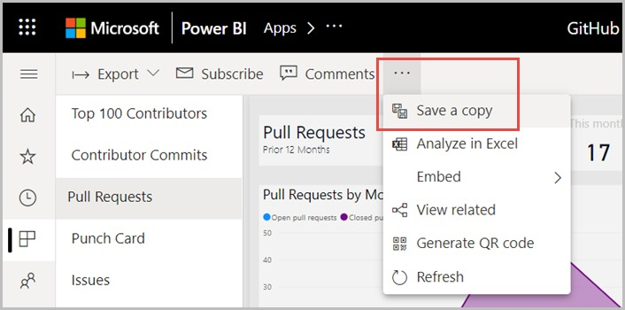

Next, fill out the title you want your viz to have and click “save”.

This message means that your connection to the Sample-Superstore data set is a live connection. Tableau Public cannot host live connections, so you’ll need to convert your connection to an extract (like a frozen screenshot of your data).

Here in the below screenshot, we can see that out workbook has been published to tableau public.

**13 LOW LEVEL DESIGN**

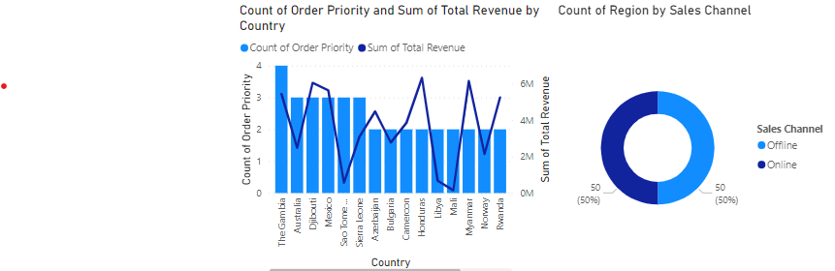

# Unit Test Cases

|  |  |
| --- | --- |
| **TEST CASE DESCRIPTION** | **EXPECTED RESULTS** |
| Year slicer | When clicked on the slicer, a dropdown should occur which has  various parameters of the Year. |
| Item Type | When clicked on the slicer, a dropdown should occur which  describes the parameters of the Item Type. |
| Relation Between Country by Year | Here a time series graph is shown of Country VS Year. |
| Relation between sales channel and units sold by region | Various city category is shown and a visualization is created  which shows the sales channels and the units sold by region. |
| Relation between unit cost by region | The visual should show a funnel chart diagram of relation between unit cost parameters across various regions. |
| Order priority of total revenue by country | This is an important visual in line and stack bar chart which shows the category Order priority of total revenue by country. |
| Region by sales channel | The visual should show a donut chart diagram of relation between Region by sales channel. |
| Total Revenue by Total cost. | The visual should show a line chart diagram of relation between Total Revenue by total cost. |